Tai Po Water Treatment Works (English) Leaflet Hong Kong
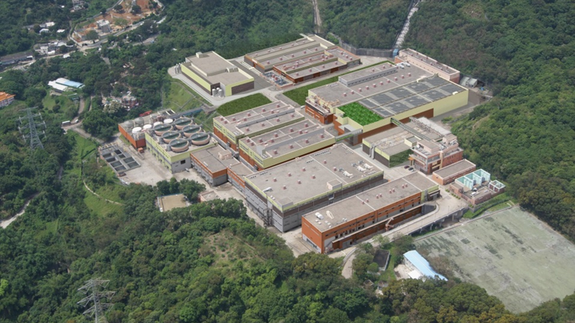
Treatment Process in Tai Po Water Treatment Works
Tunnel From Tai Po Tau “D” Pumping Station Raw Water Inlet Powdered Activated Carbon Contactor (Possible Future Pre-Ozone Tank) Inlet Chamber
Coagulation & pH Correction Flocculation Dissolved Air Floatation Plant Primary Aerated Biological Filters Manganese Reaction Tank Flocculation (for Direct Filtration Mode) Secondary Rapid Gravity Filters Chlorination & pH Conditioning Contact Tank Treated Water Reservoir and Pumping Station Treated Water to Butterfly Valley Primary Service Reservoir and Tai Po Tau Primary Service Reservoir Sludge Backwash Media Trap Supernatant Washwater Recovery Tanks Supernatant Balancing Tanks
Sludge Balancing Tanks Sludge Thickeners Sludge Holding Tanks Sludge Press Sludge Cake Treated Filtrate Package Treatment Plant
Filtrate
To Landfill Site
The quality of water is closely monitored by means of chemical, bacteriological and biological examinations of water samples taken at various stages of treatment to ensure compliance with the Guidelines for Drinking Water Quality recommended by the World Health Organization.
Tai Po Water Treatment Works
Tai Po Water Treatment Works together with Butterfly Valley Primary Service Reservoir in Kowloon and the 12 km long treated water aqueduct connecting the treatment works and the service reservoir form the Tai Po Water Scheme. The scheme provides treated water to the north-eastern part of the New Territories and the metropolitan area. Tai Po Water Treatment Works, commissioned in 2003, presently has a capacity of 250,000 cubic metres per day with provision for expansion to 1,200,000 cubic metres per day. It will become the second largest treatment works in Hong Kong when the ultimate stage is commissioned in future. The treatment works is built on a formed flat area of 10 hectares and shielded from a ridgeline to minimize visual impact. With the adoption of versatile water treatment technology and other space saving measures such as common wall and multi-level design, this hilly and constrained site can accommodate multi-stage treatment processes. To allow for possible variations in raw water quality and to ensure that treated water complies with World Health Organization (WHO) standards, the following three main treatment processes are used:
Dissolved air floatation
A robust and efficient process employs a mixture of air and water to lift coagulated solids to the water surface for subsequent removal. The rapid start-up capability of the unit can react to sudden changes in raw water quality effectively.
Aerated biological filtration
Ammonia and manganese are removed biologically under a controlled environment. The process significantly reduces the use of chlorine.
Rapid gravity filtration
The remaining turbidity in the water is removed. This is followed by final disinfection using chlorine. The concept of the treatment processes as a whole provides operational flexibility with provision for later inclusion of ozone and granulated activated carbon filters if found to be necessary. The construction of the treatment works cost about $2 billion.
IWA Project Innovation Awards – Global Grand Prize (Design Project)
The Tai Po Water Scheme won the Global Grand Prize in the Design Project category of International Water Association (IWA) Project Innovation Awards 2006. The award recognizes excellence and innovation in water engineering projects throughout the world. IWA Project Innovation Award entries were judged on their original or innovative application of new or existing technology; future value to the water engineering profession, etc.
Tai Po Water Treatment Works Layout Plan
Administration Block Inlet Chamber Treated Water Pump Station Dissolved Air Floatation Plant Secondary Rapid Gravity Filters Chlorine Store Chemical Building 1 Chemical Building 3 Chemical Building 2 Primary Aerated Biological Filters Sludge Press House Supernatant Tanks Washwater Recovery Tanks
Water Supplies Department
24-hour Telephone Enquiry Hotline: 2824 5000 Web Site Address: http://www.wsd.gov.hk E-Mail: wsdinfo@wsd.gov.hk

