UN Warns of Rising Levels of Toxic Brine as Desalination Plants Meet Growing Water Needs

World’s ~16,000 desalination plants discharge 142 million cubic meters of brine daily — 50% more than previously estimated; Enough in a year to cover Florida under a foot (30.5 cm) of brine

The fast-rising number of desalination plants worldwide — now almost 16,000, with capacity concentrated in the Middle East and North Africa — quench a growing thirst for freshwater but create a salty dilemma as well: how to deal with all the chemical-laden leftover brine.
In a UN-backed paper (“The state of desalination and brine production: A global outlook“), experts estimate the freshwater output capacity of desalination plants at 95 million cubic meters per day — equal to almost half the average flow over Niagara Falls.
For every litre of freshwater output, however, desalination plants produce on average 1.5 litres of brine (though values vary dramatically, depending on the feedwater salinity and desalination technology used, and local conditions). Globally, plants now discharge 142 million cubic meters of hypersaline brine¹ every day (a 50% increase on previous assessments).
That’s enough in a year (51.8 billion cubic meters) to cover Florida under 30.5 cm (1 foot) of brine.
The authors, from UN University’s Canadian-based Institute for Water, Environment and Health, Wageningen University, The Netherlands, and the Gwangju Institute of Science and Technology, Republic of Korea, analyzed a newly-updated dataset — the most complete ever compiled — to revise the world’s badly outdated statistics on desalination plants.
And they call for improved brine management strategies to meet a fast-growing challenge, noting predictions of a dramatic rise in the number of desalination plants, and hence the volume of brine produced, worldwide.
The paper found that 55% of global brine is produced in just four countries: Saudi Arabia (22%), UAE (20.2%), Kuwait (6.6%) and Qatar (5.8%). Middle Eastern plants, which largely operate using seawater and thermal desalination technologies, typically produce four times as much brine per cubic meter of clean water as plants where river water membrane processes dominate, such as in the US.
The paper says brine disposal methods are largely dictated by geography but traditionally include direct discharge into oceans, surface water or sewers, deep well injection and brine evaporation ponds.
Desalination plants near the ocean (almost 80% of brine is produced within 10km of a coastline) most often discharge untreated waste brine directly back into the marine environment.
The authors cite major risks to ocean life and marine ecosystems posed by brine greatly raising the salinity of the receiving seawater, and by polluting the oceans with toxic chemicals used as anti-scalants and anti-foulants in the desalination process (copper and chlorine are of major concern).
“Brine underflows deplete dissolved oxygen in the receiving waters,” says lead author Edward Jones, who worked at UNU-INWEH, and is now at Wageningen University, The Netherlands. “High salinity and reduced dissolved oxygen levels can have profound impacts on benthic organisms, which can translate into ecological effects observable throughout the food chain.”
Meanwhile, the paper highlights economic opportunities to use brine in aquaculture, to irrigate salt tolerant species, to generate electricity, and by recovering the salt and metals contained in brine — including magnesium, gypsum, sodium chloride, calcium, potassium, chlorine, bromine and lithium.
With better technology, a large number of metals and salts in desalination plant effluent could be mined. These include sodium, magnesium, calcium, potassium, bromine, boron, strontium, lithium, rubidium and uranium, all used by industry, in products, and in agriculture. The needed technologies are immature, however; recovery of these resources is economically uncompetitive today.
“There is a need to translate such research and convert an environmental problem into an economic opportunity,” says author Dr. Manzoor Qadir, Assistant Director of UNU-INWEH. “This is particularly important in countries producing large volumes of brine with relatively low efficiencies, such as Saudi Arabia, UAE, Kuwait and Qatar.”
“Using saline drainage water offers potential commercial, social and environmental gains. Reject brine has been used for aquaculture, with increases in fish biomass of 300% achieved. It has also been successfully used to cultivate the dietary supplement Spirulina, and to irrigate forage shrubs and crops (although this latter use can cause progressive land salinization).”
“Around 1.5 to 2 billion people currently live in areas of physical water scarcity, where water resources are insufficient to meet water demands, at least during part of the year. Around half a billion people experience water scarcity year round,” says Dr. Vladimir Smakhtin, a co-author of the paper and the Director of UNU-INWEH, whose institute is actively pursuing research related to a variety of unconventional water sources.
“There is an urgent need to make desalination technologies more affordable and extend them to low-income and lower-middle income countries. At the same time, though, we have to address potentially severe downsides of desalination — the harm of brine and chemical pollution to the marine environment and human health.”
“The good news is that efforts have been made in recent years and, with continuing technology refinement and improving economic affordability, we see a positive and promising outlook.”

¹The authors use the term “brine” to refer to all concentrate discharged from desalination plants, as the vast majority of concentrate (>95%) originates from seawater and highly brackish groundwater sources.
* * * * *
Authors
Edward Jones¹,², Manzoor Qadir¹, Michelle T.H. van Vliet², Vladimir Smakhtin¹, Seong-mu Kang¹,³
¹ UN University Institute for Water, Environment and Health (UNU-INWEH), Canada
² Water Systems and Global Change, Wageningen University, The Netherlands
³ Gwangju Institute of Science and Technology (GIST), Republic of Korea
* * * * *

Background
The growth of desalination
Starting from a few, mostly Middle Eastern facilities in the 1970s, today 15,906 operational desalination plants are found in 177 countries. Two-thirds of such plants are in high-income countries.
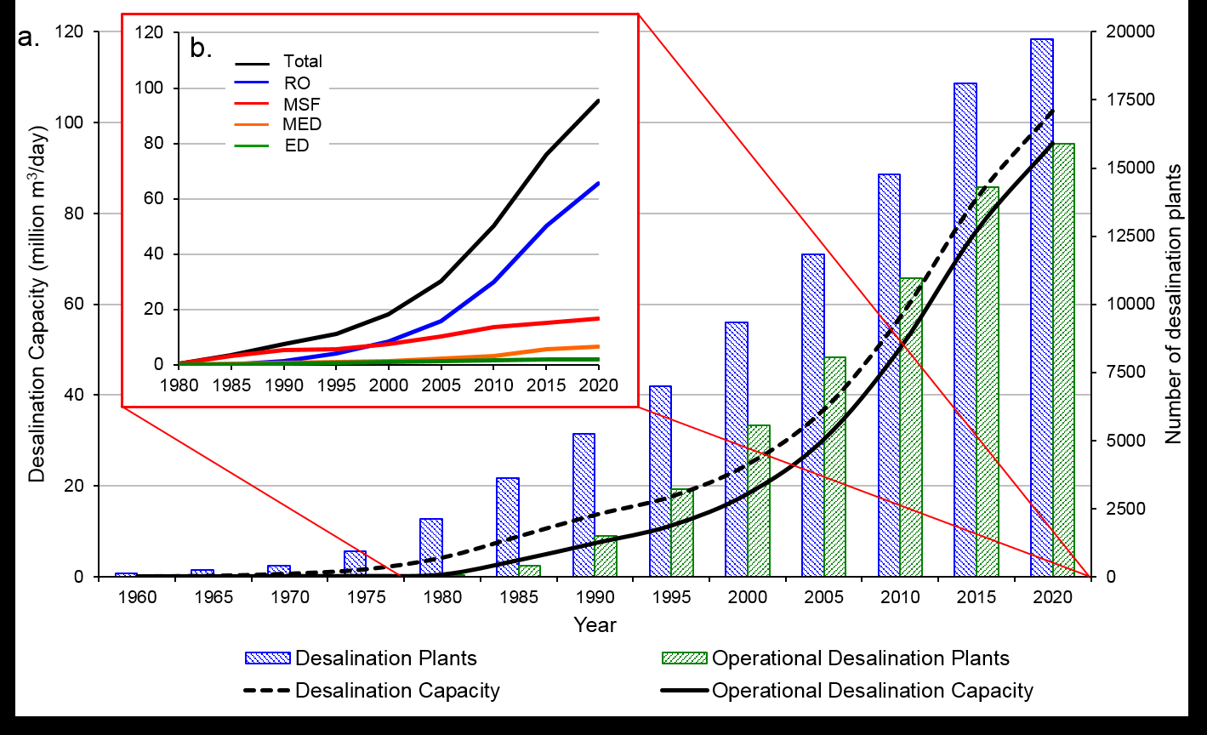
(download image in high-res: http://bit.ly/2AysFoV
The process is becoming more affordable, the paper says, attributable to falling costs due to continued improvements in membrane technologies, energy recovery systems, and the coupling of desalination plants with renewable energy sources.
Brine management can represent up to 33% of a plant’s cost and ranks among the biggest constraints to more widespread development.
Almost half of the global desalination capacity is located in the Middle East and North Africa region (48%), with Saudi Arabia (15.5%), the United Arab Emirates (10.1%) and Kuwait (3.7%) being both the major producers in the region and globally.
East Asia and Pacific and North America regions produce 18.4% and 11.9% of the global desalinated water, primarily due to large capacities in China (7.5%) and the USA (11.2%) respectively.
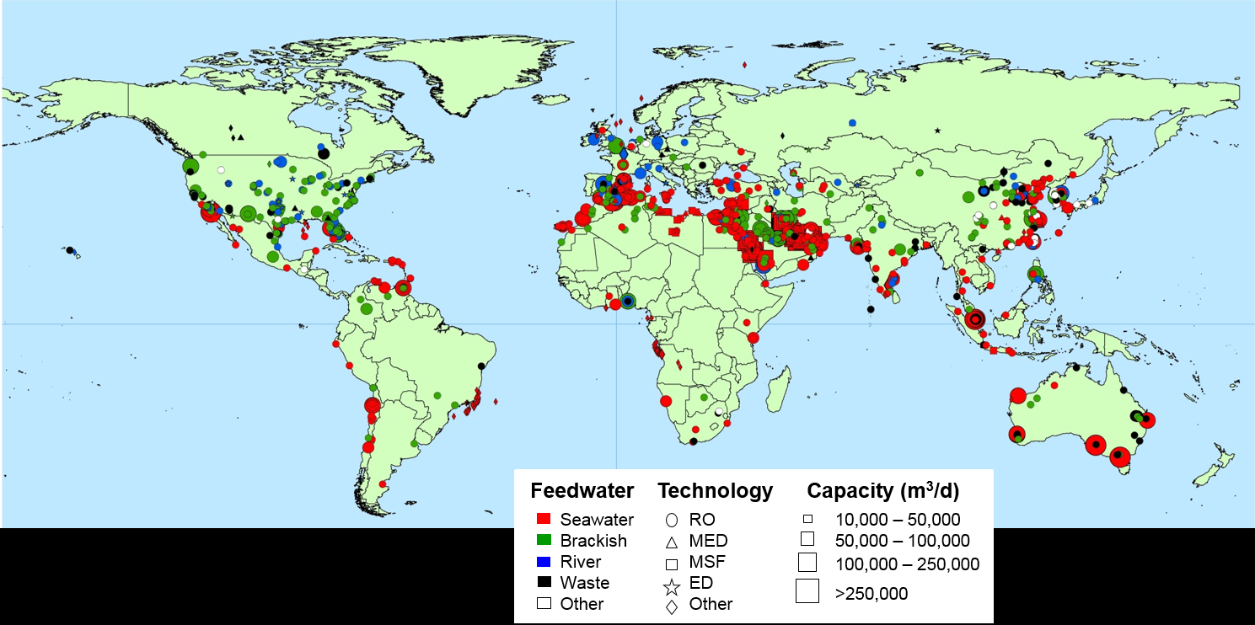
(download image in high-res: http://bit.ly/2ReUuNA)
The widespread use of desalination in Spain (5.7%) accounts for over half of the total desalination in Western Europe (9.2%). The global share in desalination capacity is lower for Southern Asia (3.1%), Eastern Europe and Central Asia (2.4%) and Sub-Saharan Africa (1.9%), where desalination is primarily restricted to small facilities for private and industrial applications.
Desalination is an essential technology in the Middle East and for small island nations which typically lack renewable water resources.
Eight countries — the Maldives, Singapore, Qatar, Malta, Antigua and Barbuda, Kuwait, The Bahamas and Bahrain – can meet all of their water needs through desalination. Six others can meet over 50% of their water withdrawals through desalination: Equatorial Guinea, UAE, Seychelles, Cape Verde, Oman and Barbados.
Almost 22 million m³/day of brine is produced at a distance of greater than 50km from the nearest coastline. Despite the large volume of brine produced in these areas, very few economically viable and environmentally sound brine management options exist. Brine produced inland poses an important problem for many countries located in all world regions, with 64 countries producing more than 10,000 m³/day of brine in inland locations.
Inland brine production is a particular issue in China (3.82 million m³/day), USA (2.42 million m³/day) and Spain (1.01 million m³/day).
The paper, “The state of desalination and brine production: A global outlook” (publisher: Science of the Total Environment, Elsevier) is available in full here.

UNU-INWEH
http://bit.ly/1vjfKAS
The UNU Institute for Water, Environment and Health is a member of the United Nations University family of organizations. It is the UN Think Tank on Water created by the UNU Governing Council in 1996. Its mission is to help resolve pressing water challenges of concern to the UN, its Member States and their people, through knowledge- based synthesis of existing bodies of scientific discovery; cutting edge targeted research that identifies emerging policy issues; application of on-the-ground scalable solutions based on credible research; and relevant and targeted public outreach.
UNU-INWEH is hosted by the Government of Canada and McMaster University.

